**Hillside Flora, Fauna, and Soil Analysis Report**

**ISAT 320**

**Dr. Coffman and Kyle Snow**

**10/2/24**

**Brian La Rosa, Jackson Smith, Kian Soltani, and Danny Diaz**

**Abstract**

This study examined the soil, flora, and fauna of hillside plots NA2 (Top of the hill), NA3 (Middle of the hill), and NA7 (Bottom of the hill) to understand their interactions and assess the overall ecological health of the region. Representative soil samples were collected and analyzed for texture, structure, nutrient content, pH, and microbial biomass. Plant species richness and diversity were determined within a designated area of the plot. Invertebrate pitfall traps were used to assess species richness and diversity of soil fauna. The findings suggest that the addition of compost can significantly alter the silt content of soil, potentially improving its water retention, aeration, and fertility properties. However, statistically significant differences were only observed for silt content when comparing natural and compost treatments and phosphorus levels. Further analysis of the waypoint chemical data revealed higher levels of most elements in the compost treatment compared to the natural treatment, although these differences were not statistically significant. This data provides a baseline for future studies geared towards monitoring soil and ecological changes in the Hillside region. Longitudinal studies are essential for understanding how soil health reacts to natural occurrences, management techniques, and environmental changes. By understanding these factors, researchers and land managers can create proactive conservation and management plans to protect the ecological integrity of the ISAT Hillside.

**Introduction**

The main objectives in this lab series are to provide a greater understanding of the Hillside plot overall ecological health. Firstly, we have to evaluate the composition of the soil by analyzing the texture, structure, and nutrient content of the soils. Next, by examining soil invertebrates as bioindicators of soil health and ecological stability, this assesses invertebrate diversity in our specific area. By fully understanding these biological elements we can get a full analysis on our samples that will help us evaluate the soil quality on the hillside plots. Third, in order to link the results to broader environmental dynamics, the series examines hydrology and erosion. Specifically we will look into how different soil qualities affect water retention and the effects of erosion on the Hillside will be over time. Finally, by creating a baseline of data that will now start monitoring soil and ecological changes in the Hillside region, we will continue the changes throughout the years to come. When taken as a whole, these goals offer a framework for comprehending this ecosystem's intricate relationships and how they relate to sustainable land management.

Each lab in this series has certain goals that we have to meet and that are meant to evaluate ecosystem dynamics and soil health on the Hillside in an extensive way. In order to provide a baseline for the soil health and biodiversity we conducted several labs to get our results. Our primary goal during the first lab is to gather and classify soil samples and invertebrates. In lab two, the amount of sand, silt, and clay in the soil is measured using hydrometry to assess the relationship between these physical characteristics and the ability of plants to thrive. In lab three, the pH and nutrient levels of the soil are measured to assess fertility and health, which is correlated with the distribution and diversity of plant species. We investigate the hydrological characteristics of soil during the fourth lab to ascertain its ability to retain water and its potential for erosion. The fifth lab consolidates information from earlier laboratories to evaluate the general health of soil and ecosystems, hence aiding in later observation and extended ecological research.

The Hillside study can also address current global environmental issues such as soil degradation, biodiversity loss, and climate change impacts. Through the examination of soil composition and hydrological characteristics, the study pinpoints variables influencing soil resilience and quality. This understanding is crucial for creating sustainable land management techniques that enhance ecological integrity and resilience to climate change. Being from concepts from *Chiras' The Nature of Soils* and *Singer's Ecology in Action*, it is evident that reliable soils are necessary for maintaining biodiversity, improving water retention, and enabling nutrient cycling. The information gathered from the Hillside project will help advance knowledge of how regional approaches might lessen these urgent global issues. Additionally, our particular plot is an essential component of a broader collaborative project in which several organizations are carrying out comparable research.

Longitudinal study is very important to discover patterns and changes in the quality of the soil throughout time. Researchers can learn numerous things about the dynamics of soil health and how it reacts to natural occurrences, management techniques, and environmental changes. While we continue to gather more data and analysis, efforts of our group will help them get a greater foundation of our findings and increase its relevance to environmental management in the real world. With patterns of climate change and human activities like urbanization or land development, the Hillside ecosystem may see changes in the diversity of plants and invertebrates, greater soil erosion, and altered nutrient cycling in the future. Researchers and land managers can create proactive conservation and management plans that protect the ecological integrity of the Hillside region by foreseeing these changes.

**Materials & Methods**

**Intro**

The goal of this lab series was to analyze soil, flora, and fauna samples of the hillside and to determine how these three factors interact with each other. Since sampling the entire hillside would take far too much time and effort the class had to use plots as representative samples. Each group was assigned a plot and the plot we were assigned was NA2. We located our plot with a GPS during the first lab period. We collected samples of all floral species within our 10 ft x 10 ft plot to identify species richness. Additionally, we counted the number of each species in random areas within a 3 ft x 3 ft subset to estimate species diversity.

Next, we randomly selected three areas within the larger plot and cut all the plants to measure wet weight biomass, while dry weight biomass was measured in a subsequent lab period. For soil sampling, we selected three random points within the 10 ft x 10 ft plot and collected soil using an auger. We also gathered data on soil texture from additional samples. To measure bulk density, we used a pipe and mallet to collect another soil sample.

Compaction testing was conducted using a penetrometer, with five readings taken across the plot to obtain a representative estimate of soil compaction. Finally, we set up two invertebrate pitfall traps in the plot, which we retrieved the following week to assess species richness and diversity of invertebrates.

During the subsequent lab period, we measured the microbial biomass of a soil sample using the microBIOMETER app, retrieved the pitfall traps, calculated invertebrate species richness and diversity, and performed trophic level calculations based on our plant biomass data. In the final lab period, we calculated soil moisture, determined bulk density, measured soil pH with a pH meter, and assessed soil texture (% sand, % clay, and % silt) using a hydrometer and various other equipment.

**3.1 Plant Identification**

All activities in this section were done on August 28, 2024 unless specifically stated otherwise.

This section involved finding and collecting a representative sample of each plant species in our 10ft x 10ft plot. Each plant was cut so that the sample would include the stem, leaves, and flower of each species (or at least however many of those three elements were present in each respective species). Each sample was cut using a hori hori tool. Once a sample of each species was cut, they were laid out in an open area for labeling and identification. Every sample was labeled with tape and a pen with the naming being based on section, group, and species number as shown below:

* S3G1 - sp1
* S3G1 - sp2
* Etc.

Once they’d been marked we used the herbarium and the field guides to identify the species of each sample. The total number of species was our species richness.

To calculate the species diversity of the area we needed to tally each individual of each species. To get a more accurate count of the entire area we would normally count each individual in the entire 10ft x 10ft plot, but this would take too much time to complete in a single lab period so we only counted the individuals in our 3ft x 3ft plot. To ensure we didn’t count any individual twice or lose track of where we were in the plot while we were counting, two group members started at the west end and very carefully moved from there to the east end while two of us were ensuring the special identities of the samples were correct.

Once we were finished tallying every individual of every species in our 3 by 3 we then moved back to the lab room and calculated the species diversity of our plot with the Simpson index of diversity and the following equation:

D = 1−∑(ni/N)^2

*“ni = the number of individuals of species i” (ISAT 320, 2024b)

*“N = the total number of individuals of all species” (ISAT 320, 2024b)

Any further details regarding the collection methods or the calculations can be found in the lab #2 handout (ISAT 320, 2024b).

**3.2 Above Ground Biomass Measurement**

All activities for this section were done on August 28, 2024 unless specifically stated otherwise.

To calculate the above ground biomass of our 10 by 10 plot we used a hula hoop to gather representative samples. The hoop can be used to easily gather those samples by simply cutting the plants that fall within the hoop once it’s thrown. Prior to throwing it we measured its diameter. Next one of us threw the hoop into the plot at three random locations and one of us cut all of the above ground plant matter contained within the perimeter of the hoop. The randomization of the spots chosen was conducted by simply tossing the hoop into the plot with no specific direction or aim. Only plants whose bases were within the perimeter of the hula hoop were cut, not plants whose tops were hanging within the perimeter but had their bases outside the perimeter. The plant matter was cut with a hori hori tool.

The plant matter of each sample was weighed in a sling attached to a balance. We accounted for the weight of the sling by hanging the empty sling from the balance and then weighing it. The mass of the sling was recorded on our data sheet. We then placed all the plant matter from each sample into the sling and weighed them one at a time. The mass of each sample was recorded in kilograms. A representative subsample of our plant biomass was placed in a paper bag and weighed (with the weight of the bag itself having been recorded already). After the rest of the plant matter had been weighed we threw it back into our plot.

In order to calculate the wet weight biomass of our plot we averaged the weights of the three samples and recorded our answer in kg/m^2. The subsample was then dried in an oven to prepare it for dry weight measurement. Those measurements were taken the following lab period (September 4, 2024).

Any further details on the measurement methods or calculations can be found in the lab #2 handout (ISAT 320, 2024b).

**3.3 Collecting Soil Samples**

All activities in this section were done on September 4, 2024 unless specifically stated otherwise.

The weight of the tin and the length of the beveled pipe (two materials required for the soil core sample collection) were measured in the lab room before going to the hillside.

To analyze the qualities and content of the soil of our plot we needed to collect a few representative and random samples. We used a random number generator to pick the three spots we sampled from. The site used was “[www.random.org](http://www.random.org)” (ISAT 320, 2024c). Two of us used a hand auger to collect the samples. Each sample was collected down to a depth of 6 inches and each sample was about a cup (¼ liter). Every sample was placed in the same plastic bag and labeled with the same notation the vegetation samples were labeled with, as well as the location, date, and time. We recorded the “date, time, weather, and visual observations” (ISAT 320, 2024c) of each spot we sampled from. Each sample was also recorded on the Chain of Custody form. The soil was mixed in the bag by inverting it several times and by crushing any large soil clumps. Each sample was weighed in the lab to ensure it was at least 800 g since 600 g was needed to send to a laboratory in Richmond for analysis and the other 200 g was needed for our in-lab work. One of the holes made by collecting the soil samples would later be used for our pitfall trap.

While we were out on the hillside, one of us gathered another soil sample from one of the sampling sites and added water to it. We each attempted to form the soil into a ball and a ribbon to see if it would fall apart or retain its shape. This test will be further described in section 3.7.

The soil core sampling required a more careful collection method since the usual collection methods would disturb the bulk density of the soil in its natural state. In order to avoid disturbing the bulk density, the group member collecting the sample had to use a beveled pipe, a wooden block, and a hammer. These materials allowed us to collect the soil without loosening or compacting it. The tin we used to store this sample was weighed while it was empty before leaving the lab room and we also measured the length of the beveled pipe before leaving the lab room as previously mentioned.

Two of us collected the soil core sample. Once we got to the hillside we located the spot we augered our other soil sample from and cleared the area around it of organic debris. The beveled pipe was then placed perpendicular to the ground with the depth markings touching the soil surface. The wooden block was placed on top of the pipe and held there by the sides as it was struck by the hammer. We continued to strike it until the pipe was driven 4.5 cm deep into the soil. The directions stated to keep hammering until 5 cm, but we stopped at 4.5 cm at the direction of Wet Labs Coordinator Kyle Snow. The hori hori tool was used to loosen the soil around the pipe in order to make pulling it out easier. We then drove the hori hori tool under the pipe before lifting it out of the ground to ensure no soil fell out while we lifted it. Once we lifted the pipe out of the ground we held it horizontally and carefully used the hori hori tool to cut away any soil that extended past the edge of the pipe.

While the soil core sample was being collected, two of us prepared the three augered samples for multiple future labs. The augered samples that had been stored in a plastic bag were dumped into a #10 sieve. Any large pebbles, gravel, and vegetation were removed. Any large soil clumps were broken up by hand. The soil was then completely sieved and stored in the collection pan. The sieved soil was used for multiple purposes. Some was placed in the Waypoint sample bag for further analysis conducted in a Waypoint lab in Richmond, some was used to fill half of a tupperware container that was air dried and used for soil fraction testing in a subsequent lab, and 200 g was stored in a plastic bag for a microBIOMETER reading in a subsequent lab.

The next step was getting the sample in the tin. We put the pipe in the tin and slowly pushed out the soil in the pipe into the tin with the handle of the hammer. Once the soil is in the tin measure its depth and diameter if possible. Note the state of your sample; whether the top is level, if it's uniform, and whether or not the shape is suitable for accurately calculating volume. Finally the lid was placed on the tin.

Once we were back in the lab room we weighed the tin with the sample inside and recorded the moist mass of the sample. The soil was then placed in an oven for drying.

Any further details regarding the collection of the augered samples, the soil core sample, or the sieving process can be found in the lab #3 handout (ISAT 320, 2024c).

**3.4 Soil Compaction Measurement**

All activities in this section were done on September 4, 2024 unless specifically stated otherwise.

Two of us conducted the compaction tests and two of us recorded the data. Determining the compaction of the soil of our plot required using a penetrometer to take five readings at five points within the plot. These readings are best taken within 24-48 hours of rainfall since the ideal conditions for determining soil compaction are when the soil is moist and near its saturation point. Our readings were taken in ideal conditions as it had rained the day before we took them. We used the smaller diameter conical point on our penetrometer at each of the 5 points.

To take the reading at each point we placed the conical point on the ground and slowly pressed down on the handle of the penetrometer until the pressure gauge reached the pressure limit in the red. We then recorded the maximum pressure and the depth of penetration. The directions state to measure the depth of penetration by loosening the wing nut and letting it drop to the soil level, tighten it again and then measure the distance between the nut and the tip. We measured the depth of penetration by placing the thumb at the spot where the shaft was touching the soil surface, pulling the tip out of the soil, and then measuring the distance between our thumb and the tip because this method was faster. It was also approved by Professor Coffman.

Any further details regarding the conduction of our compaction measurements can be found in the lab #3 handout (ISAT 320, 2024c).

**3.5 Soil Moisture and Bulk Density**

All activities in this section were done on September 18, 2024 unless specifically stated otherwise.

Calculating the soil moisture percentage of our soil sample in the tin required drying it in an oven for 24 hours. Once it had been dried we measured its dry weight. We had already measured its wet weight during lab #3 (September 4, 2024). We made sure to subtract the weight of the tin and the lid from both variables. The soil moisture percentage was calculated from there using the following equation:

Soil moisture (%) = ((Weight of wet soil - Weight of dry soil) x 100) / Weight of dry soil

Calculating the bulk density of the soil required dividing the dry weight of the sample, which we already knew from the soil moisture calculations, by the volume of the soil sample. The volume of the sample was calculated using the following equation:

πr^2h

The bulk density of the sample was calculated once the volume of the sample had been determined using the following equation:

Soil bulk density = Dry weight of the soil / Volume of soil sample

*Note that the dry weight of the soil must be in grams and the volume of the soil sample must be in cm^3.

Any further details regarding the calculations can be found in the lab #5 handout (ISAT 320, 2024e).

**3.6 Soil microBIOMETER® Readings**

All activities in this section were done on September 11, 2024 unless specifically stated otherwise

Two group members worked with the tablet and set it up. To find the “overall concentration of microbial biomass (μg C/g), % fungus, fungal concentration (μg C/g), % bacteria, and bacterial concentration (μg C/g)” (ISAT 320, 2024d) of our sample we utilized the microBIOMETER app on a tablet provided to us by our instructors.

We logged into the tablet with an email and password provided to us in the lab. Any relevant information like our group ID and plot ID was entered into the tablet and then we began making the solution that would be placed onto the sample window.

Two of us created the solution. We added the extraction powder into the extraction tube and mixed it. Then we filled the syringe with 1 mL of the sieved soil from a previous lab, compacted the soil to the 0.5 mL, and added it to the extraction tube. The solution was then mixed for 30 seconds using a whisker. Afterward we let the tube settle for five minutes, then tapped the bottom of the tube on the table four times to settle floating debris, then let it sit for another 15 minutes. Next we used a small pipette to gather some of the solution from an inch below the surface, avoiding any of the debris at the bottom. We pipetted three drops onto the sample window and waited two minutes. We aligned the blue square with the black square on the sample card and waited for the blue square to turn green to record our results. All waiting times were kept track of by using a timer on one of our phones.

Further details on the microBIOMETER readings can be found in the lab #4 handout (ISAT 320, 2024d).

**3.7 Soil Texture Analysis**

All activities in this section were conducted on September 18, 2024 unless specifically stated otherwise.

While we were in the field collecting all our soil samples from lab #3 (September 4, 2024) we collected a sample with the purpose of analyzing its texture while in the field. First we removed any large gravel, plant parts, and then added a small amount of water to the soil. We each formed the soil into a ball and a ribbon to test its ability to retain its shape without cracking or falling apart. We recorded how easy it was to mold the soil and how cracked the ribbon was on our datasheet.

**Pictured below is the soil sample we analyzed for texture:**

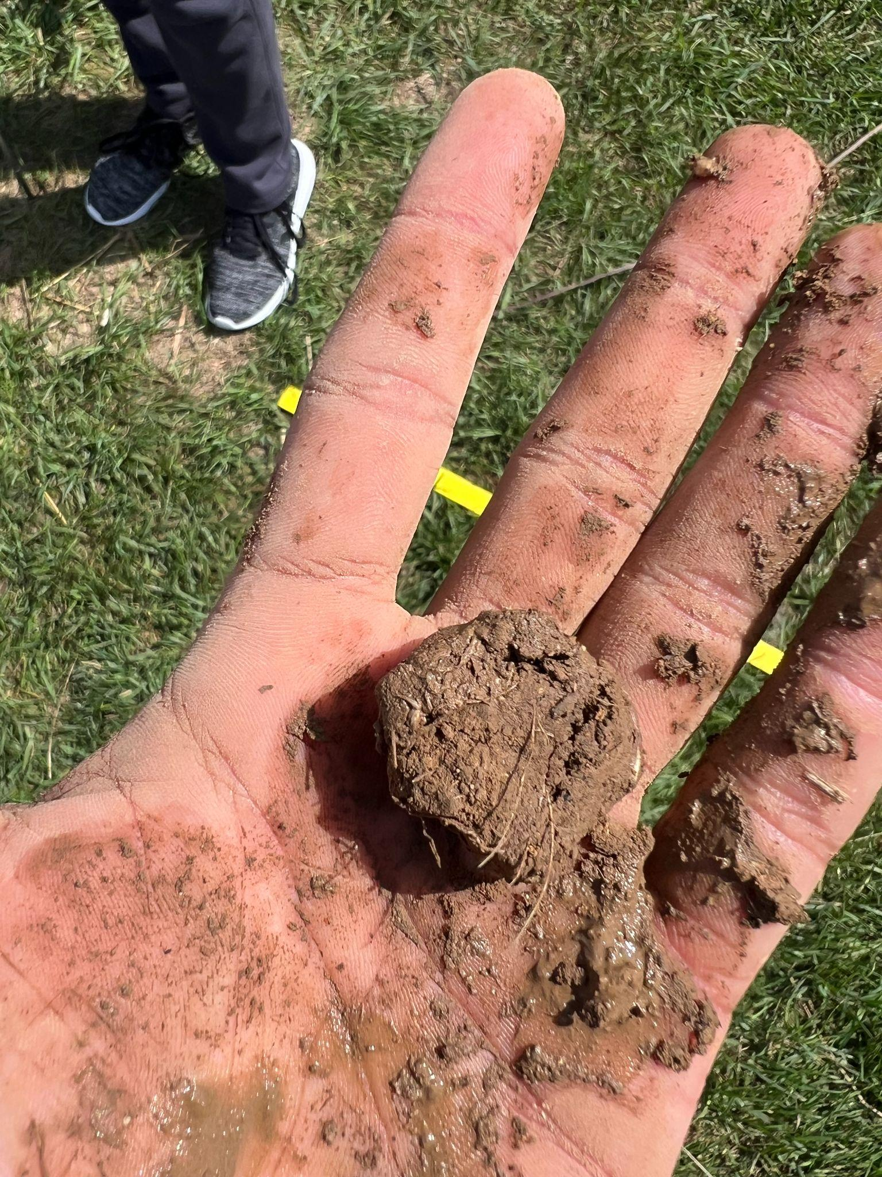

To chemically determine the texture of the soil we retrieved the sieved soil sample that was dried in an oven in section 3.3, as well as a variety of lab equipment. We precisely measured out 60.0 g of our sieved and air-dried soil in a 1000 mL beaker using a scale. The weight of the beaker itself was tared on the scale prior to adding the soil.

We then added enough deionized water to the beaker to fill it up to 700 mL. The final ingredient added was 50 mL of 0.1 N sodium hexametaphosphate to the 1000 mL beaker. The beaker was then placed on a stirring plate and mixed using the magnetic stir bar which was placed inside the beaker. The solution was mixed for 30 minutes.

During this waiting period one person was sent out to our plot to collect our second trial of the invertebrate trap that was set up during the previous lab period (September 11, 2024).

Afterward the solution was transferred to a 1000 mL graduated cylinder. Any remaining vestiges of the soil remaining in the beaker after pouring were washed out with deionized water from a squirt bottle. The suspension was mixed with a plunger, allowed to settle, and had a hydrometer placed into it. The hydrometer was placed into the suspension by Professor Coffman. We waited 40 seconds after the hydrometer was placed in the suspension to record the reading. Afterward we removed the hydrometer and placed a thermometer in the suspension. The mixing, hydrometer, and thermometer measurement process was repeated three times.

After recording all the required data from our cylinder we recorded the reading of a blank hydrometer from a cylinder with just water and sodium hexametaphosphate that was set up by the instructor as a control. We labeled our cylinder with our section and group number with the following notation:

* S3G1

Our group left the lab at that point and a further reading of the density and temperature measurements was done by the lab instructors after two hours of settling. That data was provided to us on Canvas by Professor Coffman.

Further specifics on the in-field texture analysis can be found in the lab #3 handout (ISAT 320, 2024c).

Further specifics on preparing the solution and conducting the measurements can be found in the lab #5 handout (ISAT 320, 2024e).

The following equations were used to calculate the temperature correction factor, the corrected 40-second reading, and the corrected 2-hour reading, all of which were needed to calculate the percentages of sand, silt, and clay in our sample:

**FT** = (Observed temperature - 20°C) * 0.3

*FT stands for the temperature correction factor.

**40-sec(c)** = (40-sec – Blank) + FT

*40-sec(c) stands for the corrected 40-second reading.

**2-hr(c)** = (2-hr – Blank) + FT

*2-hr(c) stands for the corrected 2-hour reading.

The following equations use the calculations above to calculate the % sand, % clay, and % silt of the soil sample:

**% Sand** = ((AD soil wt. – **40-sec(c)**) / (AD soil wt.)) x 100%

**% Clay** = ((**2-hr(c)**) / (AD soil wt.)) x 100%

**% Silt** = 100% - (**% Sand** + **% Clay**)

From there the soil’s textural class was determined using the textural triangle which can be found in the lab #5 handout (ISAT 320, 2024e).

**3.8 Soil pH**

All activities for this section were conducted on September 18, 2024 unless specifically stated otherwise.

To determine the pH of our soil we needed to make a mixture that we could test using the pH meter. First we placed a disposable weigh boat on the scale and tared it. We then poured 10 g of the field-moist soil that was sieved during lab #3 (September 4, 2024) into the weigh boat. The soil was then poured into a centrifuge tube and then we poured enough 0.01 M CaCl2 solution to fill the tube up to 45 mL. The mixture was then stirred with a spatula for 15 seconds and the cap was placed on the tube. The tube was shaken for two minutes and then placed in a centrifuge. Our sample was taken to the centrifuge by the lab’s TA, Logan Markell. The centrifuge was set to 1700 rpm for five minutes and it was balanced by the lab instructors.

Once the centrifuging of our sample was complete we transferred 20 mL of the liquid to a second clean centrifuge tube using a pipette. We also took care to only transfer the supernatant above the sediment at the bottom and below the organic matter at the top of the first centrifuge tube.

Further details on the creation, shaking, and centrifugation of the mixture can be found in the lab #5 handout (ISAT 320, 2024e).

**3.9 Invertebrate Traps and Measurements**

The activities for this section were conducted over the course of September 4 - September 18. The dates for each activity will be specified below.

In order to determine the diversity and abundance of invertebrates within our plot we had to set up a trap to collect a representative sample of the invertebrates. The collection of the invertebrates occurred over the course of two trials. The first trial was conducted from September 4 - September 11. The second trial was conducted from September 11 - September 18.

The trap was placed in one of the augered soil collection sites. The hori hori tool was used to widen the hole to ensure the trap would fit snugly. First the permanent cup was placed in the hole and then we leveled the soil around it. We then placed the collection cup into the permanent cup. In order to make the trap more flush with the soil surface we spread debris around the edges of the trap, taking care to not spill any soil or any other debris into the trap. Next we poured about an inch of soap-water solution into the collection cup. Finally the cover supports (wooden skewers) were set up around the cups and the cover was placed over top of them.

**Pictured below is our trap:**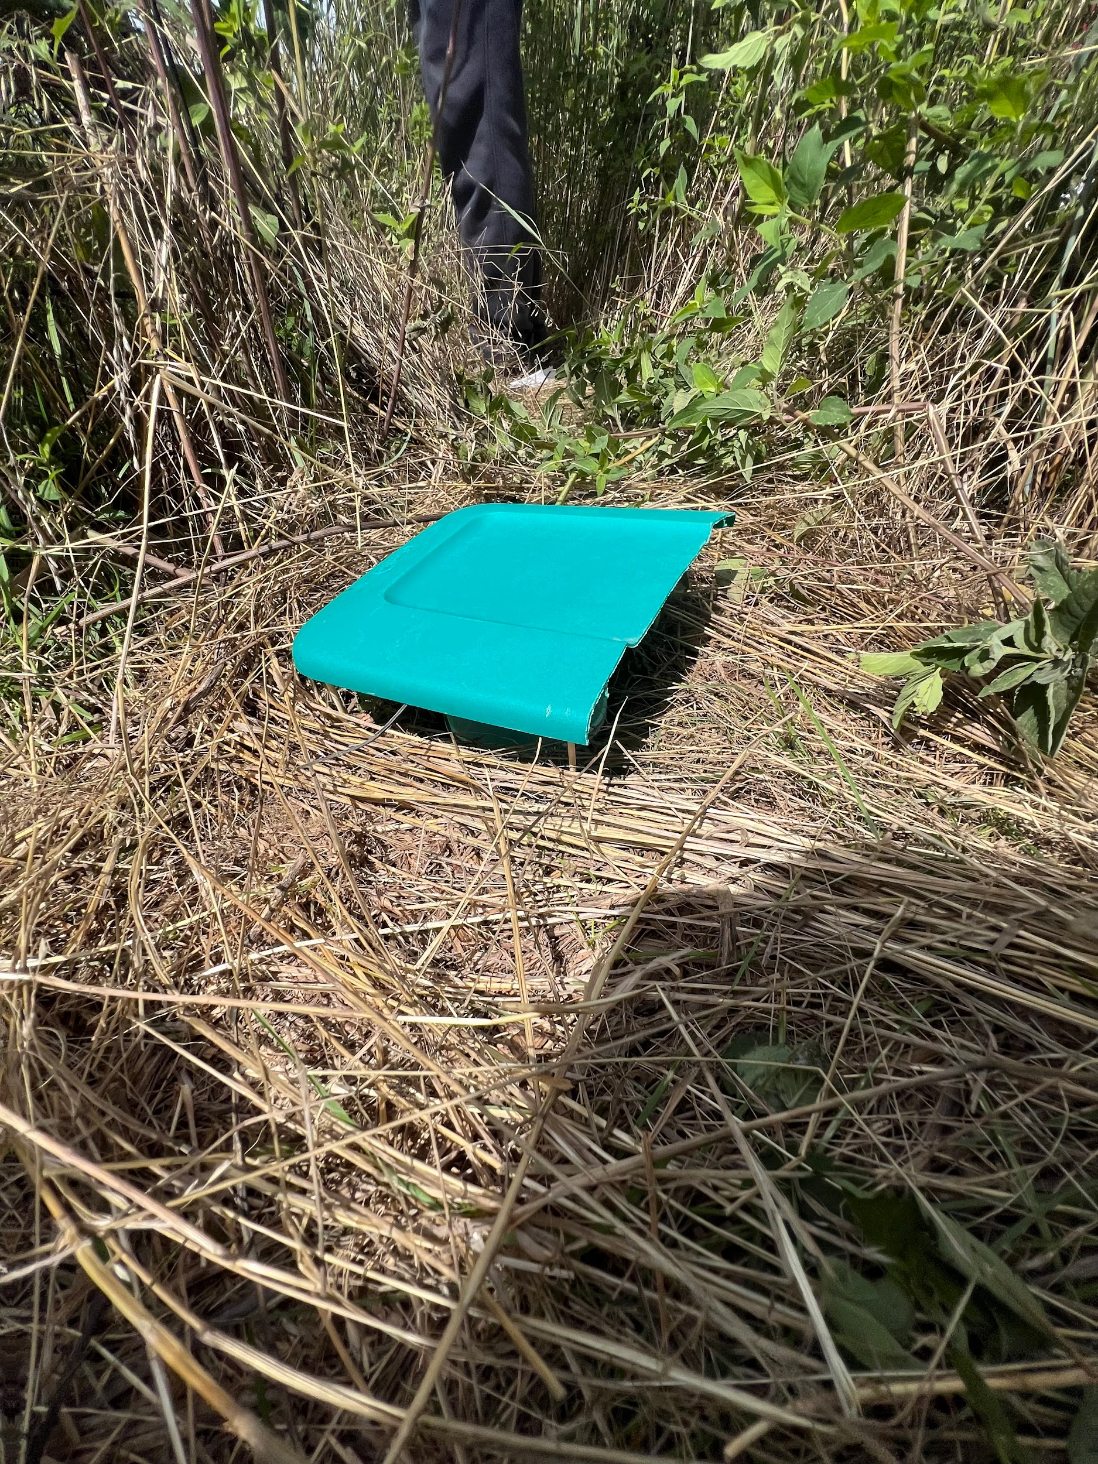

During the lab period of September 11 on which we conducted lab #4, one of us collected the trap from its hole and brought it back to the lab room to see what invertebrates we captured.

We removed the specimens from the soap-water solution using a sieve and dumped the solution down the drain. Then we placed the individual specimens on a paper towel and grouped individuals together based on likeness. We then determined to the best of our ability what species each of our specimens were and how many of each species we captured.

We determined the species richness of our plot by counting the number of species we captured and then determined the species diversity for invertebrates of our plot with the same equation we used to calculate the species diversity of the vegetation of our plot, the Simpson index of diversity equation:

D = 1−∑(ni/N)^2

The trap was reset by a group member before leaving that lab period and wouldn’t be collected again until the lab period of September 18, the period in which we conducted lab #5. This time when a group member collected the trap, the entire trap was removed and the hole was filled with soil. The plot flags our group used were also removed at this time.

Once the second trial of the trap and the specimens that came with it were returned to the lab room, we made a second round of species richness and diversity calculations using the same equation as before.

Further details on how we set up the trap can be found in the lab #3 handout (ISAT 320, 2024c).

Further details on how we calculated the species diversity of our invertebrates and how we collected our traps can be found in the lab #4 handout (ISAT 320, 2024d) and the lab #5 handout (ISAT 320, 2024e).

**4. Results and Discussion**

**4.1 Soil Analysis**

**Table 1.** This table represents the combined averages, Ranges, and Standard Deviations of both classes compared to the compost results of Penetrometer Readings, Soil Moisture, Bulk Density, clay%, silt%, and sand%. T-tests were performed and the p value is given for each measurand.

| **Penetrometer Reading** | **Natural** | **Compost** | **T-test** | **clay %** | **Natural** | **Compost** | **T-test** |
| --- | --- | --- | --- | --- | --- | --- | --- |
| Avg(cm) | 9.48 | 10.08 | 0.67 | Avg(%) | 20.8 | 15.32 | 0.09 |
| Range | 7.1 | 5.3 |  | Range | 10.1 | 11 |  |
| Std | 2.22 | 1.83 |  | Std | 3.95 | 5.06 |  |
| **sand %** | **Natural** | **Compost** | **T-test** | **silt %** | **Natural** | **Compost** | **T-test** |
| avg(%) | 30.63 | 28.16 | 0.14 | Avg(%) | 48.57 | 56.54 | 0.01 |
| Range(%) | 4.5 | 7.8 |  | Range(%) | 14.6 | 7.6 |  |
| Std | 1.76 | 2.85 |  | Std | 5.17 | 2.96 |  |
| **Soil Moisture** | **Natural** | **Compost** | **T-test** | **Bulk Density** | **Natural** | **Compost** | **T-test** |
| Avg(%) | 23.88 | 22.74 | 0.46 | Avg (g/cm3) | 1.20 | 1.12 | 0.40 |
| Range(%) | 9 | 3.7 |  | Range (g/cm3) | 0.4 | 0.4 |  |
| Std | 3.13 | 1.62 |  | Std | 0.13 | 0.15 |  |

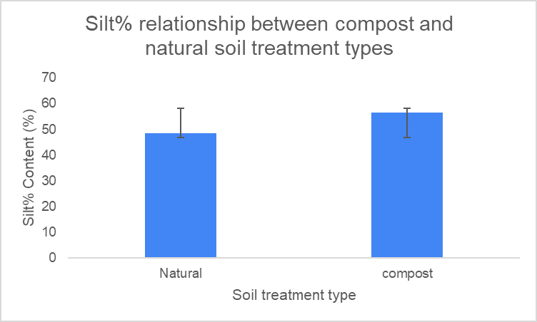

**Figure 1.** This graph shows the only statistically significant parameter for table 1. These are the averages and their error bars of silt% for each of the soil treatment types.

**Discussion of table 1**

There was only one measure that showed up as statistically significant between the two soil treatment types. Silt% was the only parameter that showed up as statistically significant with a p value of .01. This means that we can say with a 95% confidence interval that the variance between the two measurements is statistically significant. As you can see from figure 1, compost soil had an almost 10% greater amount of silt than the natural soil. Overall, the findings suggest that the addition of compost can significantly alter the silt content of soil, potentially improving its water retention, aeration, and fertility properties. The higher the silt content of the soil the greater ability of water retention, which can either be a good or bad thing depending on the weather. It can be good in the sense that if the hillside is going through a drought, the water is able to be held in the soil for longer and at a better rate, but if there is a lot of rain it will become oversaturated and erosion will occur due to runoff.

**Table 2.** This table incorporates the waypoint chemical results. This table is the natural measurements that incorporate both of the two classes. The Rows include the average, the standard deviation, and the range of each measured chemical within the soil.

| **Type of Measurement** | **Element** | **Element** | **Element** | **Element** | **Element** | **Element** | **Element** | **Element** |
| --- | --- | --- | --- | --- | --- | --- | --- | --- |
| **natural** | **Organic Matter** | **P** | **K** | **Mg** | **Ca** | **Na** | **S** | **na** |
| **avg** | 5.733 | 33.833 | 164.167 | 148.833 | 1812.667 | 10.333 | 12.667 | na |
| **std** | 1.061 | 13.005 | 44.756 | 27.334 | 1263.417 | 0.471 | 1.886 | na |
| **Range** | 2.7 | 39 | 122 | 65 | 3094 | 1 | 6 | na |
| **Natural** | **Zn** | **Mn** | **Fe** | **Cu** | **B** | **pH** | **Acidity** | **Cation Exchange Capacity** |
| **avg** | 4.500 | 71.167 | 88.000 | 1.533 | 0.650 | 6.583 | 0.717 | 11.483 |
| **std** | 0.841 | 23.864 | 23.274 | 0.269 | 0.320 | 0.773 | 0.534 | 5.933 |
| **range** | 2.6 | 61 | 68 | 0.8 | 0.7 | 2 | 1.4 | 14.4 |

**Table 3.** This table incorporates the waypoint chemical results and is the compost measurements that incorporate both of the two classes. The Rows include the average, the standard deviation, and the range of each measured chemical within the soil.

| **Measurand** | **element** | **element2** | **element3** | **element4** | **element5** | **Element 6** | **Element 7** | **Element**  **8** |
| --- | --- | --- | --- | --- | --- | --- | --- | --- |
| **compost** | **Organic Matter** | **P** | **K** | **Mg** | **Ca** | **Na** | **S** |  |
| **avg** | 7.04 | 74.8 | 215.8 | 174.8 | 1793.2 | 10.8 | 13.2 |  |
| **std** | 1.143 | 18.659 | 39.746 | 24.136 | 231.176 | 0.4 | 1.166 |  |
| **Range** | 3.5 | 46 | 110 | 72 | 659 | 1 | 3 |  |
| **Compost** | **Zn** | **Mn** | **Fe** | **Cu** | **B** | **pH** | **Acidity** | **Cation Exchange Capacity** |
| **avg** | 5.7 | 74.8 | 103.4 | 1.54 | 0.76 | 6.78 | 0.4 | 11.44 |
| **std** | 1.119 | 12.828 | 9.972 | 0.233 | 0.049 | 0.204 | 0.276 | 0.753 |
| **Range** | 3.1 | 38 | 28 | 0.6 | 0.1 | 0.6 | 0.8 | 2.3 |

**Table 4.** This table is the T-test results from comparing the measurements from the natural analysis versus the compost analysis. Any red values are statistically significant.

| **T-Test** | **Organic Matter** | **P** | **K** | **Mg** | **Ca** | **Na** | **S** |  |
| --- | --- | --- | --- | --- | --- | --- | --- | --- |
| **P- Value** | 0.115 | 0.008 | 0.101 | 0.165 | 0.974 | 0.143 | 0.616 |  |
| **Element** | **Zn** | **Mn** | **Fe** | **Cu** | **B** | **pH** | **Acidity** | **Cation Exchange Capacity** |
| **P- Value** | 0.117 | 0.778 | 0.223 | 0.969 | 0.481 | 0.606 | 0.285 | 0.988 |

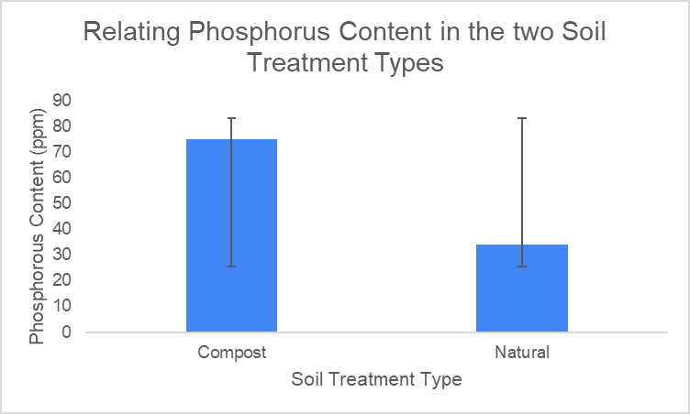

**Figure 2.** This graph shows the difference in averages of phosphorus content between the two soil treatment types.

**Discussion of waypoint chemical analysis**

Notable differences between the two soil treatments types are phosphorus and organic content percentage. While the organic content was not statistically significant between the two, the trend is that there is more organic content in the compost material. This could be because organic material leads to better structure for soil and deposits nutrients for plant growth. As one can see from figure 2, the phosphorus content in the compost material was much larger than the natural material. This makes sense, when we know that phosphorus is an essential element for plant growth, and manure, which most compost is made from, is very high in phosphorus. None of the other chemical components were statistically significant.

**4.1.2 Spatial Analysis**

**Table 5.** This table shows S1G1 and S3G1’s results for soil parameters and mineral content of plot NA2. NA2 was at the top of the hillside in reference to elevation.

| **Plot ID** | **Treatment Tpe** | **penetrometer reading** | **Bulk Density** | **Soil Moisture** | **Sand%** | **Clay%** | **Silt%** |
| --- | --- | --- | --- | --- | --- | --- | --- |
| **NA2** | **Natural/None** | cm (depth) | g/cm^3 | % | % | % | % |
| **Group ID** | **avg** | 7.9 | 1.2 | 20.6 | 32 | 24 | 43 |
| **S1G1 and S3G1** | **range** | 2.6 | 0 | 1 | 3 | 3 | 5 |
|  | **std** | 1.3 | 0.015 | 0.655 | 1.4 | 1.25 | 2.65 |
|  |  | **Organic Matter** | **Zinc (Zn)** | **Manganese (Mn)** | **Iron (Fe)** | **Copper (Cu)** |  |
|  |  | % | ppm | ppm | ppm | ppm |  |
|  | **avg** | 5.2 | 4.7 | 49.5 | 111.5 | 1.25 |  |
|  | **range** | 1.2 | 2.6 | 3 | 25 | 0.1 |  |
|  | **std** | 0.6 | 1.3 | 1.5 | 12.5 | 0.05 |  |
|  |  | **Phosphorus (P)** | **Potassium (K)** | **Magnesium (Mg)** | **Calcium (Ca)** | **Sodium (Na)** |  |
|  |  | ppm | ppm | ppm | ppm | ppm |  |
|  | **avg** | 46.5 | 194 | 136.5 | 854.5 | 10.5 |  |
|  | **range** | 25 | 12 | 33 | 241 | 1 |  |
|  | **std** | 12.5 | 6 | 16.5 | 120.5 | 0.5 |  |
|  |  | **Boron (B)** | **Soil pH** | **Acidity** | **Cation Exchange Capacity** | **Sulfur (S)** |  |
|  |  | ppm |  | meq/100g | meq/100g | ppm |  |
|  | **avg** | 0.45 | 5.9 | 1.25 | 7.2 | 12 |  |
|  | **range** | 0.1 | 0.4 | 0.3 | 1.2 | 2 |  |
|  | **std** | 0.05 | 0.2 | 0.15 | 0.6 | 1 |  |

**Table 6.** This table shows S1G2 and S3G2’s results for soil parameters and mineral content of plot NA3. NA3 is the middle of the hillside in reference to elevation.

| **Plot ID** | **Treatment Tpe** | **penetrometer reading** | **Bulk Density** | **Soil Moisture** | **Sand%** | **Clay%** | **Silt%** |
| --- | --- | --- | --- | --- | --- | --- | --- |
| **NA3** | **Natural/None** | cm (depth) | g/cm^3 | % | % | % | % |
| **Group ID** | **avg** | 12.1 | 1.2 | 24.0 | 31 | 20 | 49 |
| **S1G2 and S3G2** | **range** | 3.3 | 0.4 | 0.14 | 1.9 | 0.9 | 2.8 |
|  | **std** | 1.65 | 0.2 | 0.07 | 1.05 | 0.4 | 1.45 |
|  |  | **Organic Matter** | **Phosphorus (P)** | **Potassium (K)** | **Magnesium (Mg)** | **Calcium (Ca)** | **Sodium (Na)** |
|  |  | **%** | **ppm** | **ppm** | **ppm** | **ppm** | **ppm** |
|  | **avg** | 4.9 | 34.5 | 183.5 | 125.5 | 1000 | 10 |
|  | **range** | 0.8 | 7 | 95 | 1 | 6 | 0 |
|  | **std** | 0.4 | 3.5 | 47.5 | 0.5 | 3 | 0 |
|  |  | **Sulfur (S)** | **Zinc (Zn)** | **Manganese (Mn)** | **Iron (Fe)** | **Copper (Cu)** | **Boron (B)** |
|  |  | ppm | ppm | ppm | ppm | ppm | ppm |
|  | **avg** | 14.5 | 4 | 60 | 94 | 1.5 | 0.4 |
|  | **range** | 3 | 0.4 | 6 | 4 | 0.2 | 0 |
|  | **std** | 1.5 | 0.2 | 3 | 2 | 0.1 | 0 |
|  |  | **Soil pH** | **Acidity** | **Cation Exchange Capacity** | |  |  |
|  |  |  | meq/100g | meq/100g |  |  |  |
|  | **avg** | 6.2 | 0.9 | 7.5 |  |  |  |
|  | **range** | 0 | 0 | 0.3 |  |  |  |
|  | **std** | 0 | 0 | 0.15 |  |  |  |

**Table 7.** This table shows S1G3 and S3G3’s results for soil parameters and mineral content of plot NA7. NA7 is the bottom of the hillside in reference to elevation.

| **Plot ID** | **Treatment Type** | **penetrometer reading** | **Bulk Density** | **Soil Moisture** | **Sand%** | **Clay%** | **Silt%** |
| --- | --- | --- | --- | --- | --- | --- | --- |
| **Na7** | **Natural/None** | **cm (depth)** | **g/cm^3** | **%** | **%** | **%** | **%** |
| **Group ID** | **avg** | 8.5 | 1.2 | 27.0 | 30 | 22 | 48 |
| **S1G3 and S3G3** | **range** | 1 | 0.12 | 4.03 | 2.1 | 0.8 | 2.9 |
|  | **std** | 0.5 | 0.06 | 2.015 | 1.05 | 0.4 | 1.45 |
|  |  | **Organic Matter** | **Phosphorus (P)** | **Potassium (K)** | **Magnesium (Mg)** | **Calcium (Ca)** | **Sodium (Na)** |
|  |  | % | ppm | ppm | ppm | ppm | ppm |
|  | **avg** | 7.1 | 20.5 | 115 | 184.5 | 3583.5 | 10.5 |
|  | **range** | 0.2 | 1 | 12 | 1 | 489 | 1 |
|  | **std** | 0.1 | 0.5 | 6 | 0.5 | 244.5 | 0.5 |
|  |  | **Sulfur (S)** | **Zinc (Zn)** | **Manganese (Mn)** | **Iron (Fe)** | **Copper (Cu)** | **Boron (B)** |
|  |  | ppm | ppm | ppm | ppm | ppm | ppm |
|  | **avg** | 11.5 | 4.8 | 104 | 58.5 | 1.85 | 1.1 |
|  | **range** | 3 | 0.2 | 10 | 5 | 0.3 | 0 |
|  | **std** | 1.5 | 0.1 | 5 | 2.5 | 0.15 | 0 |
|  |  | **Soil pH** | **Acidity** | **Cation Exchange Capacity** | |  |  |
|  |  |  | meq/100g | meq/100g |  |  |  |
|  | **avg** | 7.65 | 0 | 19.8 |  |  |  |
|  | **range** | 0.1 | 0 | 2.4 |  |  |  |
|  | **std** | 0.05 | 0 | 1.2 |  |  |  |

**Discussion of plot numbers**

**Soil Parameters:**

* The penetrometer readings signify how much soil moisture there is in the area that was tested. NA3 had the highest penetration resistance, meaning that it was the most dense soil compared to plots NA2 and NA7.
* The differences in bulk density between the three plots did not seem significant enough to tell us anything about the differences in the plots.
* The soil moisture content is at its highest at the bottom of the hillside at plot NA7, followed by NA3 which is the middle, and finally the highest plot NA2 had the lowest soil moisture content.
* The percentages of silt, clay, and sand content had slight variations, but none were significantly different.

**Mineral Content**

* NA7 had the highest organic matter, followed by NA3, followed by NA2.
* NA2 had the highest phosphorus levels, followed by NA3, followed by NA2.
* Potassium, Magnesium, Calcium, and sodium levels were highest at the base of the hill(NA7), and lowest at the top of the hill(NA2).
* Sulfurinc, Zinc, Manganese, iron, Copper, and Boron had varying results across the three plots.
* NA7 had the highest pH and lowest acidity while NA2 had the lowest pH and highest acidity.
* NA7 had the highest cation exchange capacity followed by NA3, followed by NA2.

**Interpretations:**

The elevation of the plots appears to influence certain soil properties. Higher elevations (NA2) tend to have lower soil moisture, lower organic matter, and higher acidity. Lower elevations (NA7) tend to have higher soil moisture, higher organic matter, higher pH, and higher cation exchange capacity.The nutrient content of the soil varies across the plots, with NA7 generally having higher levels of most elements. This could be attributed to factors such as organic matter content, soil texture, and historical land use.NA7 appears to have the highest overall soil fertility based on its higher organic matter content, nutrient levels, and cation exchange capacity.

**4.1.3 Parameter Relationships**

Hypothesis: Soils with higher organic matter content will have better water retention and lower bulk density. We came to this hypothesis because we know from class that more organic matter content affects the structure of the soil, allowing for better water filtration and retention.

**Table 8.** This table shows the relationship between Organic Matter and Bulk Density. The data is an accumulation of all of the natural plot measurements from both sections of the class. No compost data was used in this correlation.

| **Organic Matter** | **Bulk Density** |
| --- | --- |
| **%** | **g/cm^3** |
| **4.6** | **1.21** |
| **4.5** | **1.41** |
| **7** | **1.14** |
| **5.8** | **1.18** |
| **5.3** | **1.01** |
| **7.2** | **1.26** |

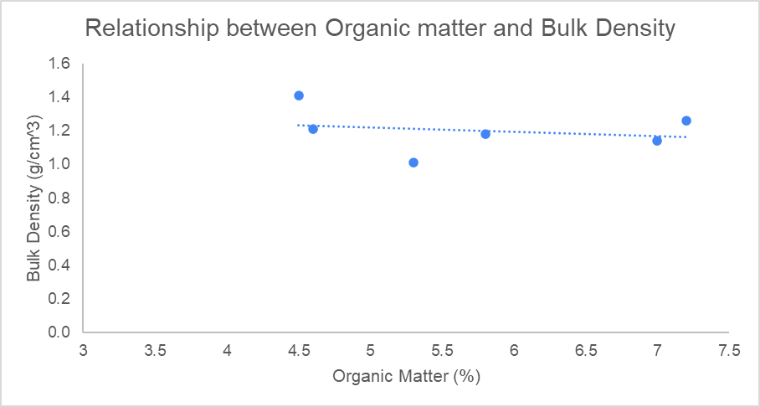

**Figure 3.** This figure shows there is a loose relationship between bulk Density and Organic Matter. The relationship seems to be that there is a negative correlation between the two parameters. The higher the organic matter leads to lower bulk density. This is not the case for every point, but it is the trend of the correlation.

**Table 9.** This table shows the relationship between Soil Moisture Content and Bulk Density. The data is an accumulation of all of the natural plot measurements from both sections of the class. No compost data was used in this correlation.

| **Soil Moisture** | **Bulk Density** |
| --- | --- |
| **%** | **g/cm^3** |
| **21.3** | **1.21** |
| **23.96** | **1.41** |
| **28.99** | **1.14** |
| **19.99** | **1.18** |
| **24.1** | **1.01** |
| **24.96** | **1.26** |

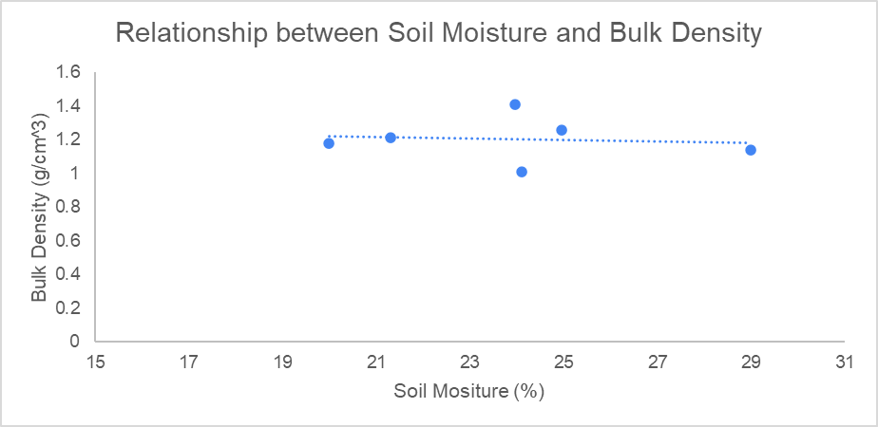

**Figure 4.** This figure shows the correlation between bulk density and soil moisture content. As you can see, based on the results of our findings there is no concrete correlation between the two parameters.

**4.1.3 Discussion**

Based on the two tables and graphs, there seems to be a poor, negative correlation between Organic matter content and Bulk Density. This correlation agrees with our hypothesis, but the correlation between Soil Moisture Content and Bulk Density had no significant correlation. So our hypothesis was partly supported by our data, but not enough to say that there is a strong correlation.

**4.1.4 Measurement Variability**

**Table 11.** This table is a collection of the soil pH measurements taken by each group.

| **Group ID** | **Plot ID** | **Treatment Type** | **Soil pH** |
| --- | --- | --- | --- |
| S1G1 | NA2 | Natural/None | 5.32 |
| S1G2 | NA3 | Natural/None | 5.96 |
| S1G3 | NA7 | Natural/None | 7.32 |
| **Group ID** | **Plot ID** | **Treatment Type** | **Soil pH** |
| S3G1 | NA2 | Natural/None | 5.22 |
| S3G2 | NA3 | Natural/None | 5.01 |
| S3G3 | NA7 | Natural/None | 5.45 |

**Table 12.** This table shows the coefficient of variability of the groups

| **Group ID** | **Plot ID** | **Coefficient of Variability** |
| --- | --- | --- |
| S1G1 and S3G1 | NA2 | 0.009487666 |
| S1G2 and S3G2 | NA3 | 0.086599818 |
| S1G3 and S3G3 | NA7 | 0.146436962 |

**Discussion**

Measurements from S1G1 and S3G1 signify a very low coefficient of variability in the measurements taken from plot NA2. This means that there was very low variance between the two measurements. This could signify that at the top of the hillside pH levels are fairly uniform throughout. Measurements from S1G2 and S3G2 can be seen as having more variance, but are still relatively similar for the two groups. Measurements from S1G3 and S3G3 were quite different and resulted in the highest coefficient of variability. This means that depending on where the measurements were taken at the bottom of the hill affects the amount of pH that was measured.

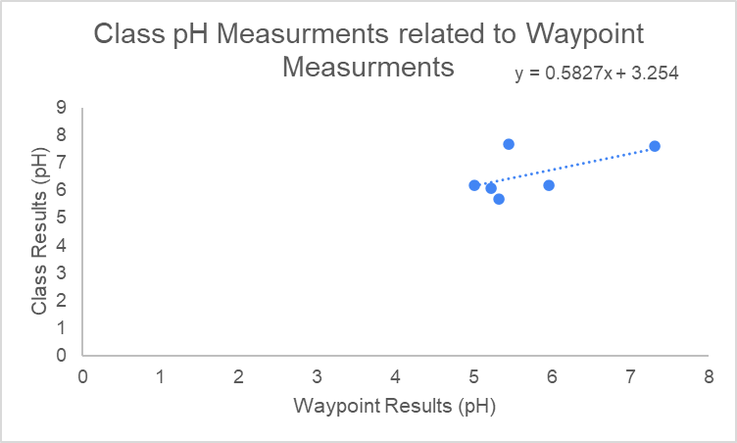

**Figure 3.** This shows the relationship between the waypoint measurements and our class measurements.

**Discussion**

A slope of one means that there is no variance, but we resulted with a slope of .58. The difference in measurements could be due to several different factors. The main factor would be a large change in temperature of the soil from when the two measurements were taken. The discrepancy can mostly be seen in the two classes group three for plot NA7. One class reported that it was 5.45 and the other reported that the soil pH was 7.35, when the waypoint result was 7.6. This difference can be linked to why the slope was so far from 1 and why we are seeing a great deal of variance in the pH measurements. Plot NA3 was also varied by almost a full pH, meaning this was also another cause of variation from being a perfect line.

**4.2.1 Plant identification**

**Table 1.** This table shows the plant species collected and incorporates the percentage of total species present within the plot and whether they were part of the original hillside planting.

| **Sample ID** | **Description** | **Species** | **% of Total Species** | **Original Hillside Planting (Y/N)** |
| --- | --- | --- | --- | --- |
| **1** | Tall grass | Switchgrass | 12.50% | Y |
| **2** | Woody Vine,  hairy leaves | Honeysuckle | 12.50% | N |
| **3** | Flower buds, brown | Wild Bergamot | 12.50% | Y |
| **4** | Fruit bearing,  green | Partridge Pea | 12.50% | Y |
| **5** | Aster | White Aster | 12.50% | N |
| **6** | Yellow flower,  small leaves | Black Eyed Susan | 12.50% | Y |
| **7** | Long stem with leaves, but at top | Showy Goldenrod | 12.50% | N |
| **8** | Small, white  flowers on thin stem | Fleabane | 12.50% | N |

**Species Richness: Total # of different species in 10 x 10 ft. plot: 8**

The differences in plant species found in our plot compared to the original hillside planting can be explained by several ecological factors such as competition, dispersal, seed viability, and habitat preferences. We only identified a few species within our plot: Partridge Pea (Chamaecrista fasciculata), Black-Eyed Susan (Rudbeckia hirta), and Wild Bergamot (Monarda Fistulosa), which make up around 13.6% of the 22 perennial flowering plants originally planted and 16.7% of the six grass species, with only Switchgrass (Panicum virgatum) being present. The lack of many original species might result from competition with faster-growing species that could outcompete more sensitive perennials. Moreover, due to poor dispersal, some plants may not have been included in the plot. Unfavorable soil conditions could also have led to low seed viability for species like Common Milkweed (Asclepias syriaca) and Butterfly Weed (Asclepias tuberosa), affecting their sprouting. Habitat preferences likely played a role, too, as certain plants may have specific needs not met in our plot. Also, the presence of unplanted species like Fleabane and Honeysuckle can be explained by opportunistic colonization; these fast-growing plants thrive in disturbed areas, allowing them to establish even though they weren’t included in the original planting. These dynamics reveal the interactions within plant communities, shaped by the ecological factors such as competition, seed viability, dispersal, and environmental conditions.

**4.2.2 Above Ground Biomass Measurements**

**Table 2.** Summary of species richness, Simpson Diversity Index, and total above-ground biomass across the two treatments.

| **Treatment** | **Species Richness** | **Simpson Diversity Index** | **Total Above Ground Biomass (g/m^2)** |
| --- | --- | --- | --- |
| Natural Hillside  (NA) | 8 | 0.67 | 150 |
| Compost Added (CP) | 10 | 0.78 | 250 |

The compost-added treatment (CP) displayed a higher species richness (10) compared to the natural hillside (NA) treatment (8). This can likely be explained due to the increased nutrients from the compost, which helps support a wide variety of plant species. For example, the Simpson Diversity Index, which increased from 0.67 in the NA treatment to 0.78 in the CP treatment, showed greater species diversity and a more even distribution of plants in the compost-added plot. Another instance could be that the total above-ground biomass was substantially more in the compost treatment (250 g/m²) than in the natural hillside (150 g/m²). This could indicate that adding compost may promote stronger plant growth by enriching the soil with nutrients. However, the t-test results imply that none of these differences were significant, with p-values of 0.21 for species richness, 0.11 for diversity, and 0.70 for biomass. Therefore, while there are observable differences, we cannot come to the conclusion with 95% confidence that the compost treatment noticeably impacted the plant richness, diversity, or biomass. These observed differences highlight the positive impact of compost application on plant community dynamics and productivity, indicating that adding compost can enhance both the diversity and biomass of plant species in a given area. The correlation between total above-ground biomass and soil parameters, like nutrient levels, moisture, and pH, is typically expected to influence plant growth. Higher nutrients, like nitrogen and phosphorus, usually promote faster growth, while adequate moisture and an optimal pH (6-7) support nutrient uptake and root development. Our data, however, didn't show a strong correlation between soil parameters and biomass. Although the compost treatment had slightly higher biomass, the results of the t-test showed no noticeable relationship between biomass and factors like moisture or pH. This could be due to factors like the small sample size or variations in soil conditions not captured in our measurements. Other factors, like competition or microclimatic differences, might have influenced biomass more than soil parameters in this case. Despite the theoretical connection, our data doesn't support any evidence of a link between soil conditions and biomass, suggesting other ecological factors are influencing the results.

**4.3 INVERTEBRATES**

| **Lab #4** | **Column1** | **Column2** | **Column3** | **Column4** | **Column5** | **Column6** | **Column7** | **Column8** | **Column9** | **Column10** |
| --- | --- | --- | --- | --- | --- | --- | --- | --- | --- | --- |
| **Dry Weight Above Ground Biomass per area** | **Microbial biomass concentration** | **Fungal to bacterial ratio** | **Fungi %** | **Fungal biomass concentration** | **Bacteria %** | **Bacterial biomass concentration** | **Invert. Species Richness, Lab #4 results** | **Invert. Diversity Index, Lab #4 results** | **Invert. Species Richness, Lab #5 results** | **Invert. Diversity Index, Lab #5 results** |
| **kg/m^2** | **μg C/g** | **F:B** | **%** | **μg C/g** | **%** | **μg C/g** |  |  |  |  |
| **0.88** | **138** | **0.1:1** | **5** | **6** | **95** | **131** | **7** | **0.62** | **5** | **0.73** |
| **0.55** | **199** | **0.2:1** | **15** | **30** | **85** | **169** | **5** | **0.66** | **3** | **0.37** |
| **0.66** | **120** | **0.1:1** | **6** | **7** | **94** | **113** | **4** | **0.61** | **6** | **0.81** |
| **0.35** | **145** | **0.0:1** | **4** | **6** | **96** | **139** | **4** | **0.30** | **4** | **0.47** |
| **0.31** | **111** | **0.0:1** | **3** | **3** | **97** | **108** | **4** | **0.74** | **2** | **0.13** |
| **0.26** | **50** | **0.0:1** | **3** | **2** | **97** | **48** | **4** | **0.67** | **2** | **0.38** |
| **0.54** | **193** | **0.1:1** | **6** | **12** | **94** | **181** | **7** | **0.68** | **6** | **0.51** |
| **0.62** | **210** | **0.1:1** | **12** | **25** | **88** | **185** | **5** | **0.75** | **4** | **0.72** |
| **0.78** | **340** | **0.3:1** | **25** | **85** | **75** | **255** | **4** | **0.56** | **2** | **0.25** |
| **0.22** | **123** | **0.0:1** | **0** | **0** | **100** | **123** | **6** | **0.80** | **2** | **0.37** |
| **1.83** | **271** | **0.4:1** | **31** | **84** | **69** | **190** | **2** | **0.08** | **2** | **0.49** |

The table above reveals a weakly positive correlation between dry weight above-ground biomass and microbial biomass concentration, implying that locations with more plant development could enable higher microbial activity. This makes sense because plants contribute to making organic matter that supplies nutrients to the soil that increase the microbe count. There is also a correlation between the fungal-to-bacterial ratio (F) and microbial biomass, particularly when the ratio rises above 0.1. This implies that the total microbial biomass of soils may be higher in those where fungi are more prevalent than bacteria.

For the invertebrates we put two trails for creating a trap for collecting invertebrates in our Hillside plot. We placed it in a spot that was out in the open and wasn’t under any vegetation; the setup was two red solo cups stacked on top of each other, the bottom cup had three holes for the invertebrates to crawl up and get trapped in the secondary cup that contained soapy water. We then had a teepee covering on top to prevent bigger animals from messing with the trap and also from preventing water and debris from getting inside the cup. For the first trial, we had set up the trap for a week and collected several species, such as Ants, Grey Large Beetle, Striped Beetle and Black Skinny Beetle. For the second trial, we had set it up for the week prior in the exact same spot from the first trial but didn't collect as many species compared to the first trial with our only results being a rolly polly and springtail. However, in the data shown above, it does not indicate a correlation between the concentration of microbial biomass and the richness of invertebrate species. This could be from the microbial abundance being more affected by external environmental circumstances or soil qualities than by the diversity of the invertebrates. Invertebrate diversity may not be a good predictor of the microbial community's abundance in this dataset despite the fact that they aid in the cycling of nutrients. In the table above, microbial biomass seems more strongly related to soil properties rather than directly to invertebrate richness or diversity. The diversity index, ranging from 0.08 to 0.80, also fluctuates across the Hillside. A lower index, such as 0.08, correlates with low richness and microbial biomass, potentially indicating areas with less ecological complexity. In our plot, although other groups in our lab section were successful in attaining higher species richness, we were able to gather six different species. Our score was roughly 0.67 and 0.38 on the diversity index, which indicates a low diversity. This puts us below those with greater richness and diversity indices but in line with some other groups, indicating that our habitat might not support as diverse an invertebrate community as those in more biodiverse plots.

**Conclusion**

This study provides valuable insights into the current state of soils and ecology on the Hillside, which focuses on key factors such as plant species richness, above-ground biomass, microbial activity, and invertebrate diversity. Our findings indicate that compost application has the ability to improve the plant community by increasing both species richness and total above-ground biomass when compared to the natural hillside treatment. However, the t-test results illustrate that these differences are statistically insignificant, which could mean that while compost may encourage plant growth, other ecological factors are also influential in this. The unplanted species like Fleabane and Honeysuckle emphasizes the interactions within the plant community, which shows the need for more examination of competition and habitat preferences.

The slight positive relationship we observed between microbial activity and above-ground biomass suggests that healthier plant growth could lead to an increase in microbial populations, likely because of the organic matter produced by plants. In addition, a correlation between the fungal-to-bacterial ratio and microbial biomass implies that soils dominated by fungi may support larger microbial communities. In contrast, the absence of a correlation between invertebrate species richness and microbial biomass suggests that external environmental factors could have a greater effect on microbial communities compared to invertebrate diversity. Finally, the differences in diversity index values across the Hillside indicate varying levels of ecological complexity. Lower values are linked to reduced microbial activity and fewer plant species.

There are many recommendations that can be considered in order to make improvements to the ecological health and understanding of the Hillside. For instance, we could perform further testing with many compost treatments that could help pinpoint the optimal conditions for improving nutrient availability and plant resilience. Long-term monitoring of soil health—including moisture, pH, and nutrient levels—alongside assessments of plant and microbial communities would offer a more comprehensive understanding of the Hillside's ecological dynamics. Lastly, doing more investigation into the effects of diverse native plant species, especially those that are currently missing, could contribute to restoring balance within the ecosystem.

A comprehensive and holistic approach that combines experimental treatments with ongoing monitoring is crucial if we are to improve the hillside’s ecological health and biodiversity. The steps outlined will help deepen our understanding of the relationships between plants, microbes, and soil and thus will foster a healthier, more resilient overall ecosystem.

**References**

Haahr, M. (n.d.). *RANDOM.ORG - True Random Number service*. RANDOM.ORG. <https://www.random.org/>

ISAT 320 Coffman (2024a). Lab #1: Introduction to Environmental Sampling. Retrieved from

<https://canvas.jmu.edu/courses/2036196/assignments/18873847?module_item_id=40287665>

ISAT 320 Coffman (2024b). Lab #2: Vegetation Sampling. Retrieved from <https://canvas.jmu.edu/courses/2036196/assignments/18873853?module_item_id=40287675>

ISAT 320 Coffman (2024c). Lab #3: Physical Properties of Soils. Retrieved from <https://canvas.jmu.edu/courses/2036196/assignments/18873854?module_item_id=40287687>

ISAT 320 Coffman (2024d). Lab #4: Invertebrate Sampling, microBIOMETER, and Trophic Level Estimations. Retrieved from <https://canvas.jmu.edu/courses/2036196/assignments/18873855?module_item_id=40287698>

ISAT 320 Coffman (2024e). Lab #5: Physical Properties of Soils, pt. II. Retrieved from <https://canvas.jmu.edu/courses/2036196/assignments/18873846?module_item_id=40287708>